ABSTRACT

Smart Event Management System is a web-based application developed to simplify and modernize the process of planning, organizing and booking events. Traditional event management methods often involve manual coordination, lack of real-time updates, limited customization options and complex booking procedures. This system addresses these challenges by providing a centralized digital platform that enhances efficiency, accessibility and user experience.
The system offers innovative features such as voice-based registration, allowing users to interact with the platform easily and conveniently. Real-time availability tracking enables customers to instantly check venue status, service options and booking schedules without delays. Users can also select and customize event packages according to their preferences, including venue type, catering services, decoration themes and entertainment options.
Instant notifications keep users informed about booking confirmations, updates, reminders and changes ensuring smooth communication between clients and event organizers. Additionally, the system includes a comprehensive admin panel that allows administrators to manage bookings, update event details, monitor availability and control website content efficiently.
By integrating automation, real-time data management and user-friendly design, the Smart Event Management System reduces manual workload, improves transparency, enhances customer satisfaction and streamlines overall event operations. This solution provides a modern, reliable and scalable approach to managing events in a digital environment.

CHAPTER – 1

INTRODUCTION

INTRODUCTION
1.1 PROJECT OVERVIEW

The Smart Event Management System is a web-based application developed to simplify and automate the process of event planning and management. The project aims to provide a centralized platform where users can easily book, customize and manage events online without the need for manual coordination.

In traditional event management systems, customers often face difficulties such as lack of real-time information, complicated booking procedures, limited customization options and delayed communication. This project addresses these issues by introducing smart features such as voice-based registration, real-time availability checking, customizable event packages and instant notifications.

The system allows users to browse available venues and services, select event types (such as weddings, corporate meetings, birthday parties, etc.), customize packages according to their preferences and complete bookings online. Once a booking is made, users receive immediate confirmation and updates through notifications.

An integrated admin panel enables administrators to efficiently manage bookings, update event details, monitor schedules and maintain customer records. The admin can also control website content, track event status and ensure smooth operation of the system. The primary goal of this project is to enhance user convenience, reduce manual work, improve communication and provide a modern digital solution for event management. The system is designed to be user-friendly, efficient, reliable and scalable for future enhancements.

1.2 OBJECTIVES

- Develop a user-friendly web-based platform for event planning and booking.
- Simplify the event registration and booking process through online access.
- Provide voice-based registration for improved accessibility and ease of use.
- Enable real-time availability checking for venues and services.
- Offer customizable event packages based on user preferences and budget.
- Send instant notifications for booking confirmation, updates and reminders.
- Reduce manual paperwork and minimize human errors.
- Create an efficient admin panel for managing bookings and event details.

It allows customers to register, log in and manage their profiles securely. It enables users to browse events, check real-time availability and customize event packages based on their preferences. Users can book events, make payments online and receive instant notifications about confirmations and updates. This module ensures a smooth and user-friendly experience throughout the event booking process.

- ADMIN MODULE

It allows administrators to manage and control the entire system efficiently. It enables them to view and manage bookings, update event details, monitor availability and maintain user records. The admin can also handle notifications, manage website content and generate reports to ensure smooth system operations.

SYSTEM STUDY

2.1 EXISTING SYSTEM
In the existing system, event booking is mostly handled manually, which often leads to delays and human errors. There is no real-time availability tracking for services and dates, making it difficult for customers to know whether their preferred schedule is available. Event packages are usually fixed and cannot be customized according to individual needs. Additionally, there is no support for voice-based registration, limiting accessibility for users. Notifications and communication between customers and administrators are inefficient, resulting in poor coordination and slower updates.

LIMITATIONS:
- Manual booking process causes delays and human errors.
- No real-time availability of venues and services.
- Event packages cannot be easily customized.
- No voice-based registration or smart accessibility features.
- Poor notification and communication system

2.2 PROPOSED SYSTEM

The proposed Smart Event Management System is a web-based platform designed to automate and simplify event planning and booking. It provides real-time availability of venues and services, allowing users to check and book events instantly. The system offers customizable event packages and voice-based registration for better accessibility. Users receive instant notifications for confirmations and updates, while the admin panel efficiently manages bookings and event details. This system reduces manual work, improves accuracy, and enhances overall user experience.

ADVANTAGES:

- Real-Time Availability
- Reduced Manual Work
- Error Minimization
- Easy Online Booking
- Secure Payment System
- Customizable Packages
- Voice Registration Support
- Instant Notifications
- Improved Communication
- Time Saving

2.3 FEASIBILITY STUDY
A feasibility study is conducted to evaluate whether the proposed Smart Event Management System is practical, achievable, and beneficial. It helps determine if the project can be successfully developed and implemented using available resources, technology, and time.
- TECHNICAL FEASIBILITY
This study checks whether the required technology, tools and technical resources are available to develop the system. The Smart Event Management System can be developed using modern web technologies and does not require highly complex infrastructure, making it technically feasible.

- ECONOMIC FEASIBILITY
Economic feasibility analyses the cost involved in developing and maintaining the system compared to the benefits it provides. The system reduces manual work, saves time, improves efficiency and making the investment cost-effective.

- OPERATIONAL FEASIBILITY
Operational feasibility determines whether the system will function effectively in the real environment and whether users can easily operate it. The system is designed with a user-friendly interface, making it simple for both customers and administrators to use.

CHAPTER-3

REQUIREMENT ANALYSIS

REQUIREMENT ANALYSIS

3.1 BLOCK DIAGRAM

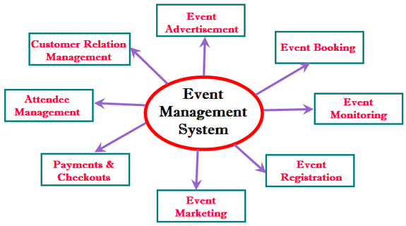

CHAPTER- 4
SYSTEM ANALYIS

SYSTEM ANALYSIS

4.1 DATA FLOW DIAGRAM

LEVEL 0 DFD

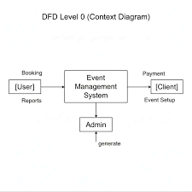

Level 1 DFD

Data flow diagram level- 1

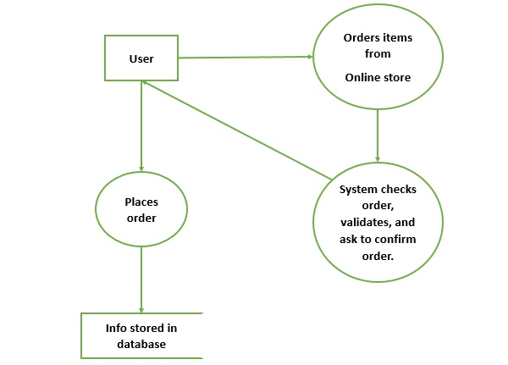

Level 2 DFD

Data flow diagram for administrator context level- 1

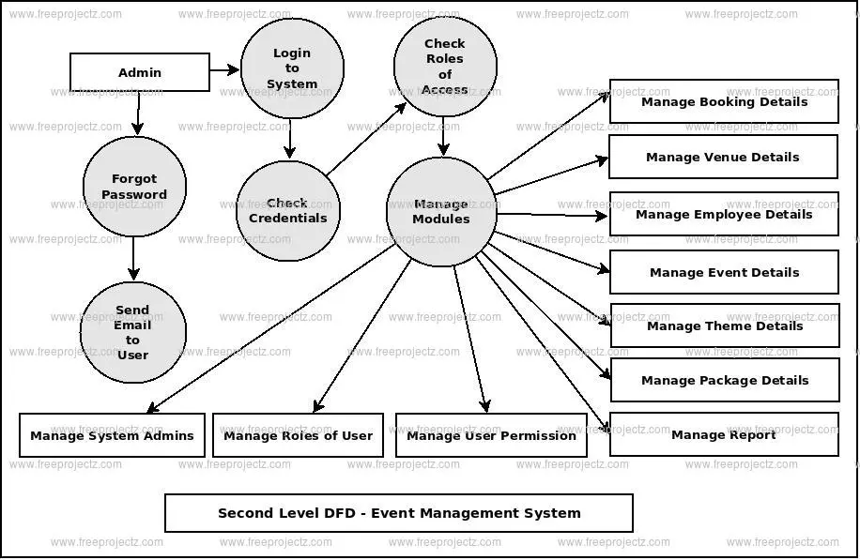
4.2 ENTITY RELATIONSHIP DIAGRAM

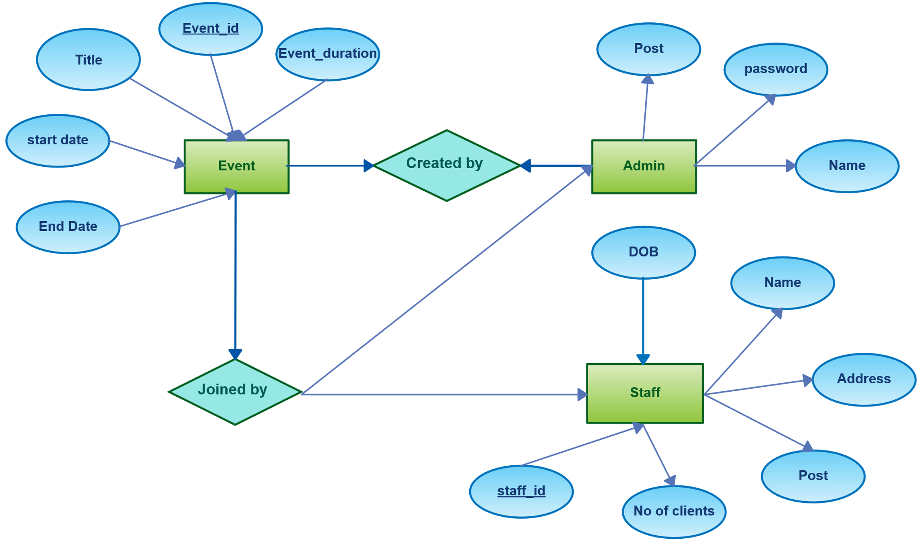
Chapter- 5

SYSTEM REQUIREMENTS SPECIFICATIONS
SYSTEM REOUIREMENT SPECIFICATION

5.1 HARDWARE REQUIREMENTS
The Event Management System requires the following hardware components to ensure proper functioning of the application.

Server Hardware

- Processor: Intel Core i5 or higher
- RAM: Minimum 8 GB
- Storage: 256 GB SSD or higher
- Network: High-speed internet connection (minimum 10 Mbps)
- Backup Device: External storage for data backup

Client Hardware

- Processor: Intel Core i3 or higher
- RAM: Minimum 4 GB
- Storage: 100 GB available disk space
- Display: 1366 × 768 resolution or higher
- Input Devices: Keyboard and mouse
- Network: Internet connection for accessing the system

5.2 SOFTWARE REQUIREMENT

The Event Management System requires specific software to support the development, operation, and maintenance of the application. The system can run on operating systems such as Windows 10, Windows 11, or Linux. For development purposes, programming languages and web technologies like HTML, CSS, JavaScript, and server-side languages such as Java, Python, or PHP may be used. An integrated development environment (IDE) such as Visual Studio Code, Eclipse, or IntelliJ IDEA can be used to write and manage the code. The system requires a database management system such as MySQL or PostgreSQL to store and manage data related to users, events, registrations, and bookings. A web server like Apache, Nginx, or Node.js is required to host and run the application. The system can be accessed using modern web browsers such as Google Chrome, Mozilla Firefox, or Microsoft Edge. Additionally, software packages such as XAMPP or WAMP may be used to create a local server environment during development, and version control tools like Git can be used to manage and track project changes.

- Frontend: HTML, CSS, JavaScript

- Backend: Node.js + Express

- Database: MySQL

HTML:
HTML (HyperText Markup Language) is the fundamental language used for creating and structuring web pages on the internet. It is a markup language that defines the structure and layout of web content by using a system of tags and elements. HTML allows developers to organize text, images, audio, video, links, tables, and other multimedia content in a structured format so that web browsers can display them properly. It acts as the backbone of every website and is essential for web development.
HTML documents consist of a series of elements represented by tags enclosed in angle brackets. These tags instruct the web browser on how to display the content on a webpage. An HTML document usually starts with a <!DOCTYPE html> declaration followed by the <html> element. Inside it, the <head> section contains metadata such as the title of the page, links to stylesheets, and scripts, while the <body> section contains the visible content displayed to users. HTML provides several tags such as headings (<h1> to <h6>), paragraphs (<p>), images (<img>), hyperlinks (<a>), lists (<ul>, <ol>), and tables (<table>) to organize content effectively.
HTML is often used along with CSS (Cascading Style Sheets) and JavaScript to build complete web applications. While HTML is responsible for structuring the content, CSS is used to control the visual appearance such as colors, fonts, layouts, and spacing. JavaScript is used to add interactivity and dynamic behavior to the web pages, such as form validation, animations, and user interactions. Together, these technologies form the core foundation of modern web development.
In software and web development projects, HTML plays a significant role in creating user interfaces and presenting information clearly to users. It helps in building responsive and accessible websites that can be viewed on different devices such as computers, tablets, and smartphones. Modern versions like also support advanced features such as multimedia elements, semantic tags, and improved form controls, which make web pages more interactive and user-friendly.
Because of its simplicity, flexibility, and wide browser support, HTML has become the most widely used language for designing websites and web-based applications. It allows developers to create structured and organized web pages efficiently, making it an essential technology in the field of web development.

CSS:
CSS (Cascading Style Sheets) is a style sheet language used to control the presentation and appearance of web pages created with HTML. It is mainly used to design and format the layout of a webpage, including colors, fonts, spacing, alignment, and overall visual structure. CSS helps developers separate the design from the content, making websites more organized, attractive, and easier to maintain. By using CSS, developers can apply consistent styles across multiple web pages in a website.
CSS works by selecting HTML elements and applying styles to them using rules. A CSS rule consists of a selector and a declaration block. The selector identifies the HTML element to be styled, while the declaration block contains properties and values that define how the element should appear. For example, CSS can change text color, adjust font size, add background images, and control page layout. This allows developers to create visually appealing web pages that improve user experience.
There are three main types of CSS used in web development: Inline CSS, Internal CSS, and External CSS. Inline CSS is applied directly within an HTML element using the style attribute. Internal CSS is written within the <style> tag inside the HTML document’s <head> section. External CSS is written in a separate .css file and linked to the HTML document. External CSS is the most commonly used method because it allows developers to manage styles for multiple pages from a single file.
CSS also provides advanced features such as responsive design, animations, transitions, and flexible layouts. Modern CSS technologies like Flexbox and Grid allow developers to design responsive layouts that adapt to different screen sizes and devices. This helps ensure that websites look good and function properly on desktops, tablets, and mobile phones.
In web development projects, CSS plays a vital role in enhancing the visual presentation of a website. It improves the usability and accessibility of web pages by making them more attractive and easy to navigate. By combining CSS with HTML and JavaScript, developers can create modern, interactive, and professional-looking websites.

JAVA SCRIPT:
JavaScript is a widely used programming language for creating dynamic and interactive web pages. It is mainly used to add functionality and behavior to websites developed using HTML and CSS. JavaScript allows developers to create interactive features such as form validation, animations, image sliders, pop-up messages, and dynamic content updates. It runs directly in the user's web browser, which makes websites more responsive and user-friendly.
JavaScript works by executing scripts within a web page to control and modify HTML elements and CSS styles. It can respond to user actions such as clicks, mouse movements, keyboard input, and page loading events. Through the use of functions, variables, and objects, JavaScript enables developers to build complex web applications. It also interacts with the Document Object Model (DOM), which represents the structure of the webpage and allows JavaScript to update the content and layout dynamically.
One of the key advantages of JavaScript is its ability to create real-time interaction without reloading the entire webpage. For example, JavaScript can validate user input in forms before submission, display alerts or notifications, and load new content dynamically. This improves the performance and usability of websites. Modern JavaScript also supports advanced features such as asynchronous programming, APIs, and frameworks that help developers build powerful web applications.
In web development projects, JavaScript plays an important role in enhancing user experience by making websites more interactive and engaging. It works together with HTML, which provides the structure of the webpage, and CSS, which controls the design and layout. By combining these technologies, developers can create modern, responsive, and feature-rich websites and web applications.
Because of its flexibility, speed, and strong community support, JavaScript has become one of the most important programming languages in web development. It is widely used in building web applications, mobile applications, and even server-side development, making it an essential technology for modern software development.

NODE.JS+EXPRESS:
Node.js is an open-source, server-side runtime environment that allows developers to run JavaScript code outside the web browser. It is built on the Chrome V8 JavaScript engine and is widely used for building fast and scalable network applications. Node.js uses an event-driven and non-blocking architecture, which makes it efficient for handling multiple requests simultaneously. This feature makes Node.js very suitable for developing real-time applications such as chat applications, online games, and web servers.
Node.js allows developers to use JavaScript for both frontend and backend development, which simplifies the development process. It also provides access to a large number of open-source libraries through the Node Package Manager (NPM). These packages help developers easily add functionalities such as database connectivity, authentication, file handling, and API integration into their applications. Because of its speed and scalability, Node.js has become a popular choice for modern web development.
Express.js is a lightweight and flexible web application framework built on top of Node.js. It simplifies the process of building web applications and APIs by providing a set of useful features and tools. Express helps developers handle routing, middleware, HTTP requests, and responses more efficiently. It reduces the amount of code required to build server-side applications, making development faster and easier.
Express.js is widely used for developing RESTful APIs and backend services. It allows developers to create routes that respond to different HTTP methods such as GET, POST, PUT, and DELETE. Middleware functions in Express help process requests, manage sessions, handle errors, and perform authentication. These features make Express a powerful framework for building scalable and maintainable web applications.
In modern web development projects, Node.js and Express are commonly used together to build the backend of web applications. While Node.js provides the runtime environment for executing JavaScript on the server, Express simplifies the process of handling server operations and routing. Together, they provide a powerful platform for developing fast, efficient, and scalable web applications.

MYSQL:
MySQL is an open-source relational database management system (RDBMS) that is widely used for storing, managing, and retrieving data in web applications. It uses Structured Query Language (SQL) to perform operations such as inserting, updating, deleting, and retrieving data from the database. MySQL organizes data into tables consisting of rows and columns, making it easier to manage large amounts of information efficiently. Because of its reliability, speed, and security, MySQL is commonly used in many web-based applications.
MySQL supports relational database concepts such as tables, relationships, primary keys, and foreign keys, which help maintain data accuracy and consistency. Developers can create multiple tables and establish relationships between them to organize data effectively. This structure helps reduce data duplication and ensures efficient data management. MySQL also supports indexing, which improves the speed of data retrieval and query performance.
One of the major advantages of MySQL is its compatibility with many programming languages and web technologies, including HTML, CSS, JavaScript, Node.js, PHP, and pyhton

CHAPTER- 6

SYSTEM DESIGN

SYSTEM DESIGN
6.1 Table design

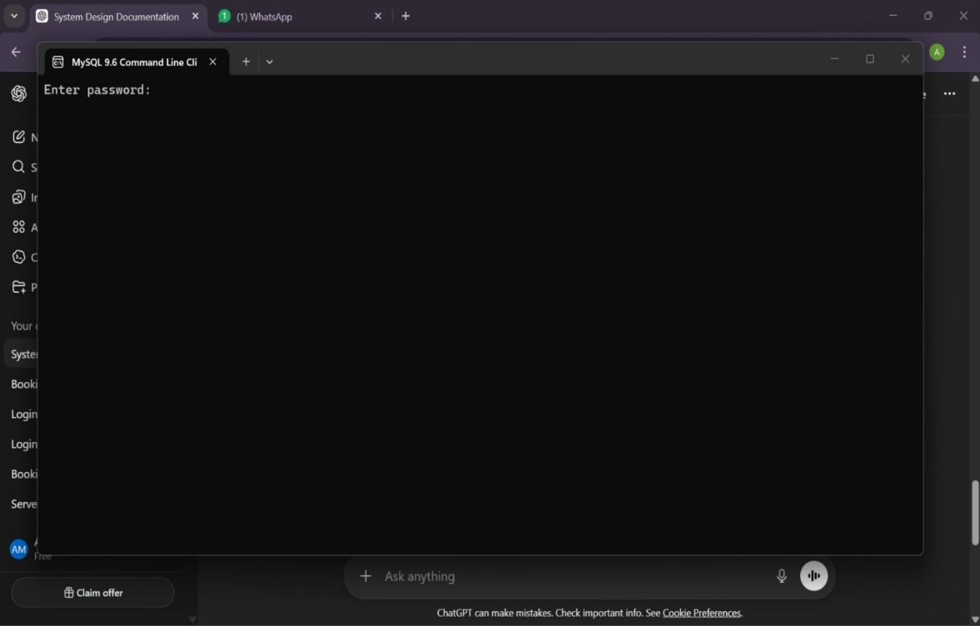

Figure 6.1.1: Admin Login

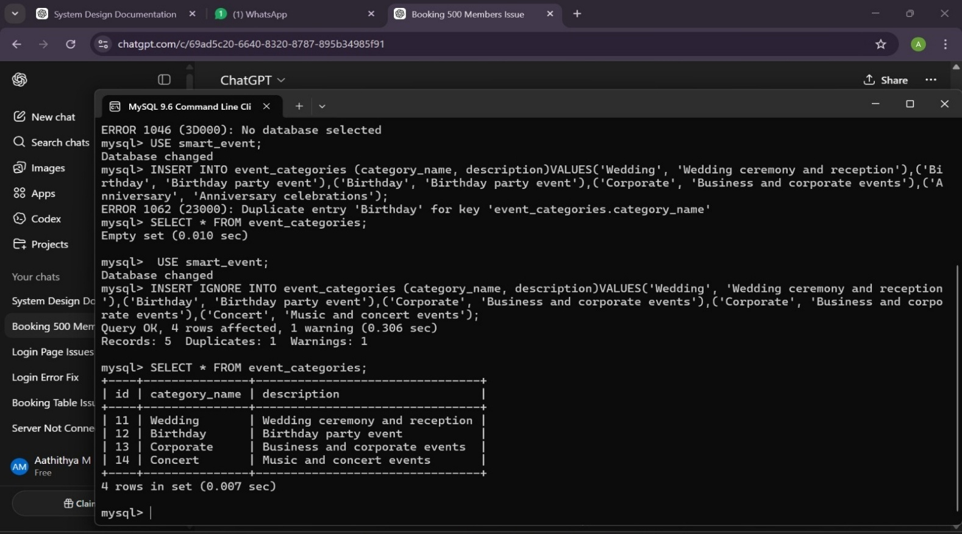

Figure 6.1.2: Event Category Database

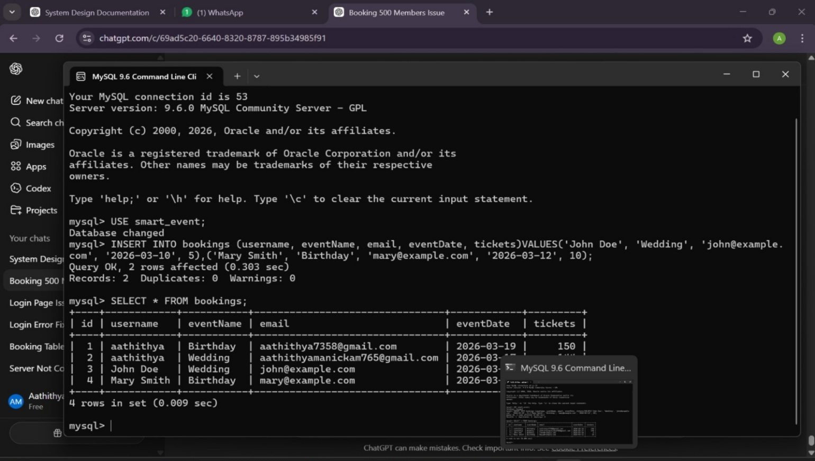

Figure 6.1.3: table booking database

6.2 INTERFACE DESIGN
The interface design of the Event Management System is created to ensure a smooth, simple, and efficient interaction between the user and the system. The main objective of the interface is to provide an easy-to-use platform where users can quickly access different features related to event planning and management. The system includes a well-structured homepage that displays important information about upcoming events, services offered, and navigation options. Users can easily move between different sections such as event registration, event schedule, booking services, and contact details through clearly designed menus and buttons.
The design focuses on clarity and usability by using proper alignment, readable fonts, suitable colors, and organized layouts. The registration and login pages allow users and administrators to securely access the system. Once logged in, users can view available events, check event details, and book services according to their requirements. The admin interface allows event organizers to manage event details, update schedules, monitor registrations, and handle customer information effectively. Forms are designed with clear input fields and validation features to ensure accurate data entry.
The interface also includes interactive elements such as buttons, navigation bars, images, and icons to make the system more engaging and visually appealing. Responsive design techniques are applied so that the system can function properly on different devices such as desktops, laptops, tablets, and smartphones. This ensures that users can access the system anytime and from anywhere without difficulty.
Overall, the interface design of the Event Management System aims to improve user experience by providing a well-organized, responsive, and visually attractive platform. It helps users easily interact with the system, manage event-related activities, and access information efficiently, making the event planning process more convenient and effective.

